

Student Name | Kashvi Shetty
SRN No | 31230726
Roll No | 37
Program | Computer Engineering
Year | Third Year
Division | D
Subject | Computer Network Laboratory (BTECCE21506)
Assignment No | Six

Assignment Number - 06

Title : Configuration of router for implementation of Open Shortest Path First (OSPF) Protocol

Problem Statement Using a Network Simulator (e.g. packet tracer) Configure routers for OSPF routing

OSPF Protocol
OSPF is a complex routing protocol. It uses many terms to define its functions and operations.
Link
A link is a router's interface connected to an IP subnet. When we add an interface to the OSPF process, OSPF considers the interface as a link.
State
Since a link is an interface, it has two states: up and down. The up state shows the link (interface) is operational and OSPF can reach the IP subnet connected to the link. The down state shows the link is not operational and OSPF cannot reach the IP subnet connected to the link.
Link state protocol
OSPF is a link-state protocol. Link state protocols use the Shortest Path First (SPF) algorithm to calculate the best path to a destination. To run this algorithm, link-state protocols learn the complete topology of the network. In a big size network, this feature creates scalability problems. To solve this problem, OSPF uses two concepts: autonomous systems and areas.
An autonomous system
Term | Description
Backbone area | A special area to which all other areas must connect.
area | A set of contiguous routers that share the same routing information.
Backbone routers | Routers in the backbone area
Internal routers | Routers in areas off the backbone
ABR | A router that connects the area to the backbone area
Intra-area route | A route within the same area
Interarea route | A route between the areas
An autonomous system is a group of networks under a single administrative control which can be a group of companies, a company, or a division within the company. There are two types of routing protocols: Interior Gateway Protocol (IGP) and Border Gateway Protocol (BGP). IGP routing protocols provide routing within a single AS. BGP routing protocols provide routing between different AS. OSPF is a IGP routing protocol. OSPF provides routing within a single AS.

OSPF Area
OSPF groups network together, where the topology of one group is hidden from the other. These set of groups are called Areas. An area ID is 32 bit number, which is unique identification number that differentiates each area.
Backbone area (Area 0) – Responsible for distributing routing information among other areas of the system. The backbone area is identified by the number 0.0.0.0
Off backbone area (Area 1-65535) – consist of areas other than backbone area of system.

Configuration of OSPF
The systax for configuring OSPF is:
Router(Config)#router ospf process_ID
Router(Config)#network Network_address Wildcard_mask area are_no

OSPF Implementation with Single Area

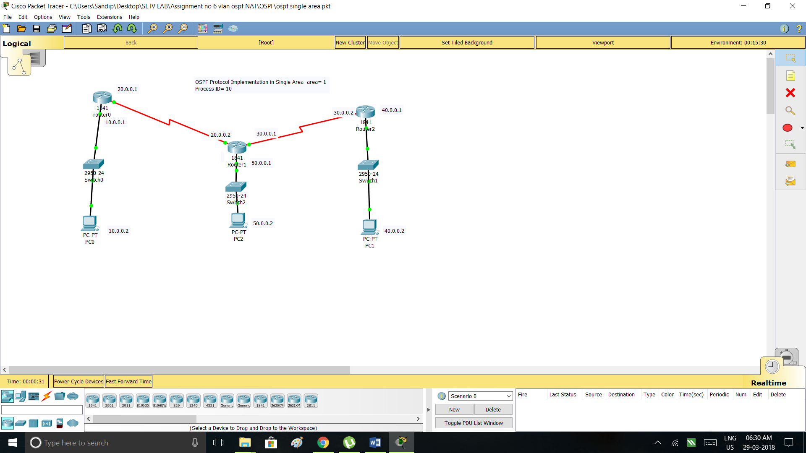

OSPF Implementation in Multiple Area

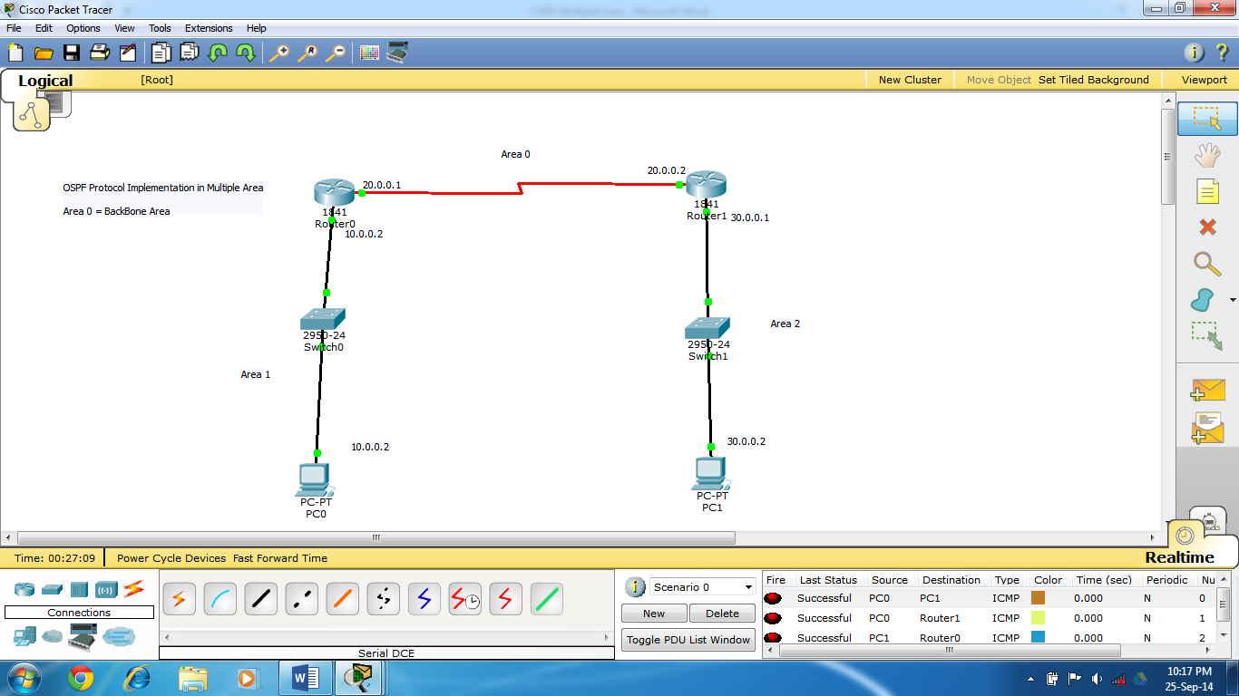

Router#show ip protocols

Routing Protocol is "ospf 10"
Outgoing update filter list for all interfaces is not set
Incoming update filter list for all interfaces is not set
Router ID 30.0.0.1
Number of areas in this router is 3. 3 normal 0 stub 0 nssa
Maximum path: 4
Routing for Networks:
20.0.0.0 0.255.255.255 area 0
30.0.0.0 0.255.255.255 area 2
Routing Information Sources:
Gateway Distance Last Update
20.0.0.1 110 00:06:51
30.0.0.1 110 00:05:18
Distance: (default is 110)

